Pizza Sales SQL Queries

**A.KPI’s**

1.Total Revenue:

select sum(total_price) as Total_Revenue from Pizza_Sales;

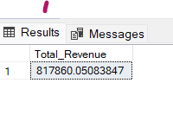

**2.Average Order Value:**

select (sum(total_price)/count(distinct order_id)) as Avg_order_value from Pizza_Sales;

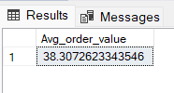

**3.Total Pizzas Sold:**

select sum(quantity) as Total_Pizza_Sold from Pizza_Sales;

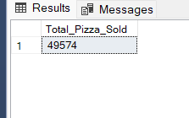

**4.Total Orders:**

select count(distinct(order_id)) from Pizza_Sales;

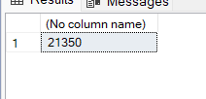

**5.Average Pizzas Per Order:**

select cast(cast(sum(quantity) AS Decimal(10,2))/cast(count(distinct(order_id)) AS decimal(10,2)) AS Decimal(10,2)) from pizza_sales;

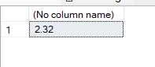

**B. Daily Trend for Total Orders**

select DATENAME(DW,order_date) as order_day , count(Distinct(order_id)) as Total_orders

from Pizza_Sales

group by DATENAME(DW,order_date)

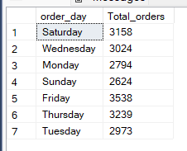

**C. Monthly Trend for Orders**

select DATENAME(Month,order_date) as Month_name , count(Distinct(order_id)) as Total_orders

from Pizza_Sales

group by DATENAME(Month,order_date)

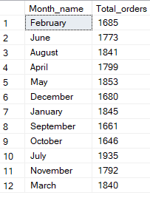

**D. % of Sales by Pizza Categories**

select pizza_category, sum(total_price)*100/(select(sum(Total_price)) from pizza_sales) as perct_total_sales from pizza_sales

group by pizza_category

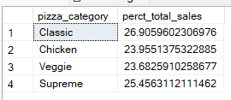

**E.% of Sales by Pizza Size**

select pizza_size, sum(total_price)*100/(select(sum(total_price)) from Pizza_Sales) from pizza_sales

group by pizza_size

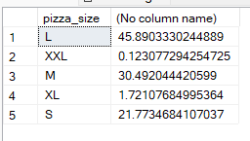

**F. Total Pizza Sold by Pizza Categories**

Select pizza_category ,sum(quantity) as Total_Quantity_sold

from Pizza_Sales

group by pizza_category

order by sum(quantity)desc

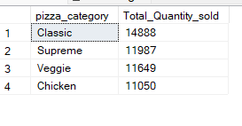

**G. Top 5 Pizza by Revenue**

select top 5 pizza_name , sum(total_Price) as Total_Price

from Pizza_Sales

group by pizza_name

order by sum(total_price) desc

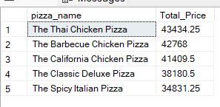

**H. Bottom 5 Pizza by Revenue**

select top 5 pizza_name , sum(total_Price) as Total_Price

from Pizza_Sales

group by pizza_name

order by sum(total_price) asc

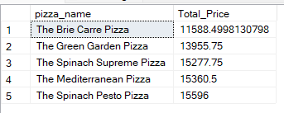

**I. Top 5 Pizza by quantity:**

select top 5 pizza_name , sum(quantity) as total_pizza_sold

from Pizza_Sales

group by pizza_name

order by total_pizza_sold desc

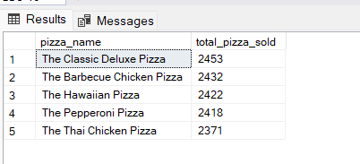

**J.Bottom 5 Pizza by Quantity:**

select top 5 pizza_name , sum(quantity) as total_pizza_sold

from Pizza_Sales

group by pizza_name

order by total_pizza_sold asc

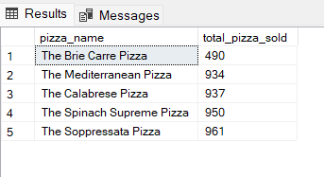

**K.Top 5 pizza by Total Orders:**

select top 5 pizza_name , count(distinct(order_id)) as total_pizza_order

from Pizza_Sales

group by pizza_name

order by total_pizza_order desc

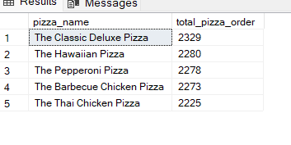

**L. Bottom % pizza by Total Orders:**

select top 5 pizza_name , count(distinct(order_id)) as total_pizza_order

from Pizza_Sales

group by pizza_name

order by total_pizza_order asc

